Lab 8: Static Sequential Memories and Tri-State Buses

Author: Seth Ricks
Lab Partner: Ian Fleming
Date: 11/18/2025
Class: ECEN 340

Purpose:
- To learn how to design Static Memories
- To learn how to deal with tri-state (3-state) data buses
- To learn to trust simulation for sub modules
- To gain experience understanding Verilog code written by someone else.

Procedure:
Part 1. Simulating a single 16 X 16 Static memory.
a) Design the 16 X 16 Static RAM module called "memory". Note that the cell ports are: we, oe, data, addr, and clk. The data is accessed via a bi-directional 16-bit bus. See class slides for details on memory arrays (class slides are duplicated below).

b) Write a test bench to verify functionality of the memory (class slides are duplicated below).

module memory(
input wire oe, we, clk,
input wire [14:0] addr,
inout wire [7:0] data
);
reg [7:0] mem [32767:0];

assign data = (oe && !we) ? mem[addr]:8’hzz;
always@(posedge clk)
begin
if (we) mem[addr] <= data;
end
endmodule
Note: The above code will synthesize a memory that is 32768 X 8bit. Understand the difference between this memory and the 16 X 16bit memory of this lab.

module memory_tb( );
reg we, oe, clk;
wire [7:0] data;
reg [3:0] addr;
reg [7:0] data_temp;
parameter period = 10;
memory u0 (.we(we), .oe(oe), .clk(clk), .data(data), .addr(addr));

assign data = we?data_temp:8'hZZ;
always #(period/2) clk = ~clk;
initial
begin clk = 0; oe = 0; we = 0; addr = 4’h0; data_temp = 8’h00;
#5 we = 1'b1;
@(posedge clk)
#1 addr = 4'h0; data_temp = 8'h34; // wait 1 ns before writing
#period addr = 4'h1; data_temp = 8'h58; // writing to memory
#period addr = 4'h2; data_temp = 8'hA5;
#period addr = 4'h3; data_temp = 8'h5A;
…
#period addr = 4'h0; we= 1'b0; oe = 1'b1; // reading from memory
#period addr = 4'h1;
#period addr = 4'h2;
…
#1000 $finish
end
endmodule
Note: The above code is a test bench excerpt for the memory module.
Part 2. Implement the complete lab in Vivado. Homework 8 will serve as the foundation for understanding this lab. You will need:
1) Your four digit 7-segment display modules.
2) Your "memory" module
3) The pre-written modules provided.

You will not need to write a test bench for this part of the lab. When the lab is completely implemented, you will observe that the top-level design instantiates two 16 X 16 SRAM cells, 5 push-button debouncers, and the seven-segment design of Lab 6.

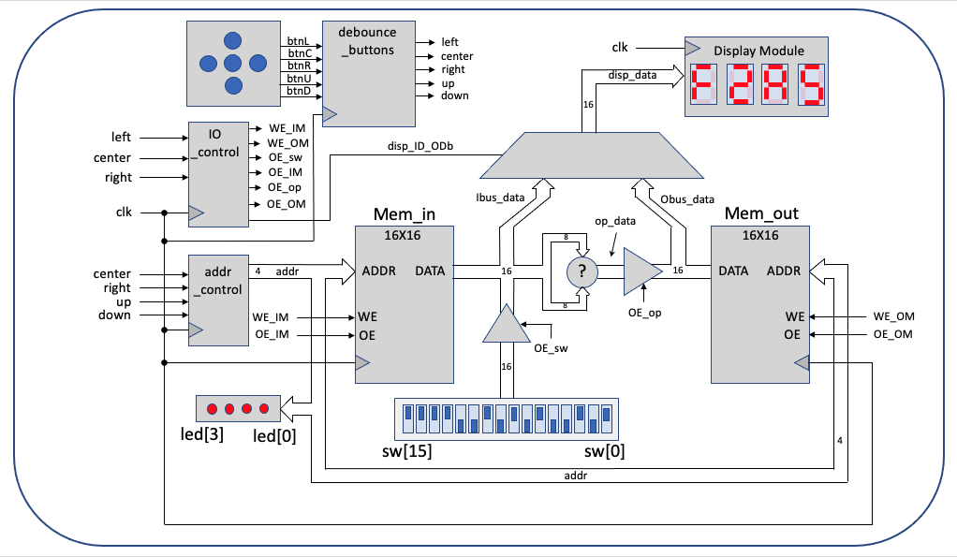
Block Diagram of 3-state Memory Lab

Results/Report:
This entire lab was based on the premise that we need to be able to read and understand someone else’s code. It was difficult for me, not only because of the lack of useful comments, but because of the density of the code. Despite this, my lab partner and I were able to complete the lab successfully, and I learned a valuable lesson about adding comments to my code.

Part 1:
In this part of the lab, we were instructed to use the two excerpts of code provided to simulate a single 16x16 static memory. This was straightforward and didn’t take very long. We had to change a few things in the code to make it work. The first thing we changed was the depth of the register array. Because we were creating a 16x16 static memory, we changed the array in the code to be reg [15:0] mem [15:0]. This can be seen in Figure 1 below.
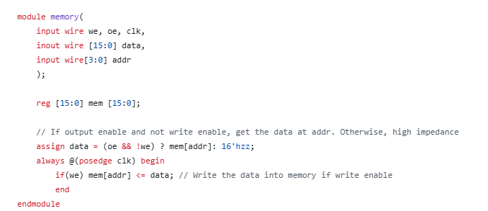
Figure 1: 16x16 Static Memory Module

We also made some changes to the testbench code. We added some more temporary data to store in all 16 addresses, so that we could get a full depth of testing the memory module. An image of our testbench code can be seen in Figure 2 below.

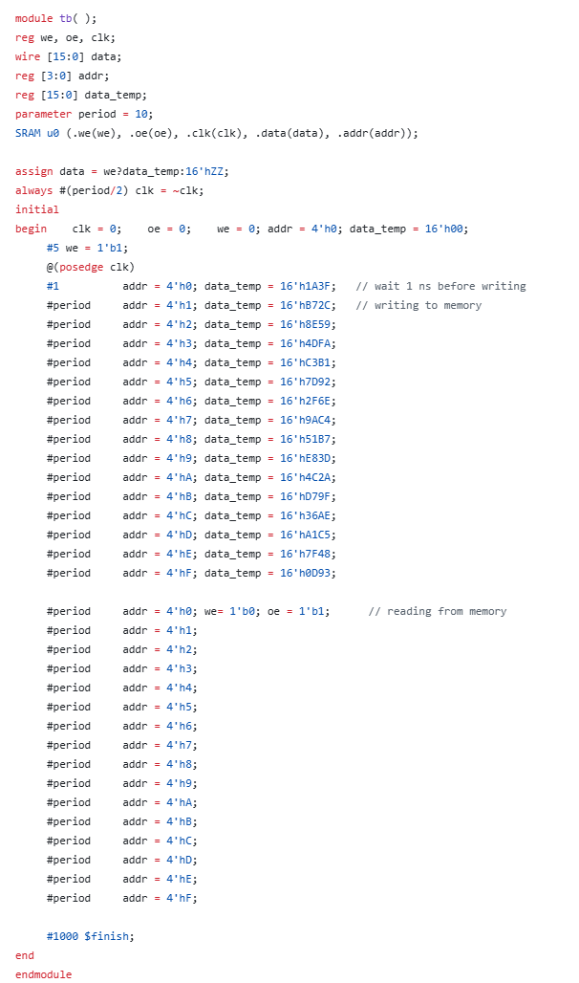
Figure 2: Part 1 Testbench Code

We ran our simulation for our memory module, and it worked! This can be seen in Figure 3. The changing addresses can be seen in the last line of the waveforms. The test data written to those addresses can be seen in the data_temp[15:0] and the data[15:0] lines of the waveforms. This concludes Part 1 of the lab.
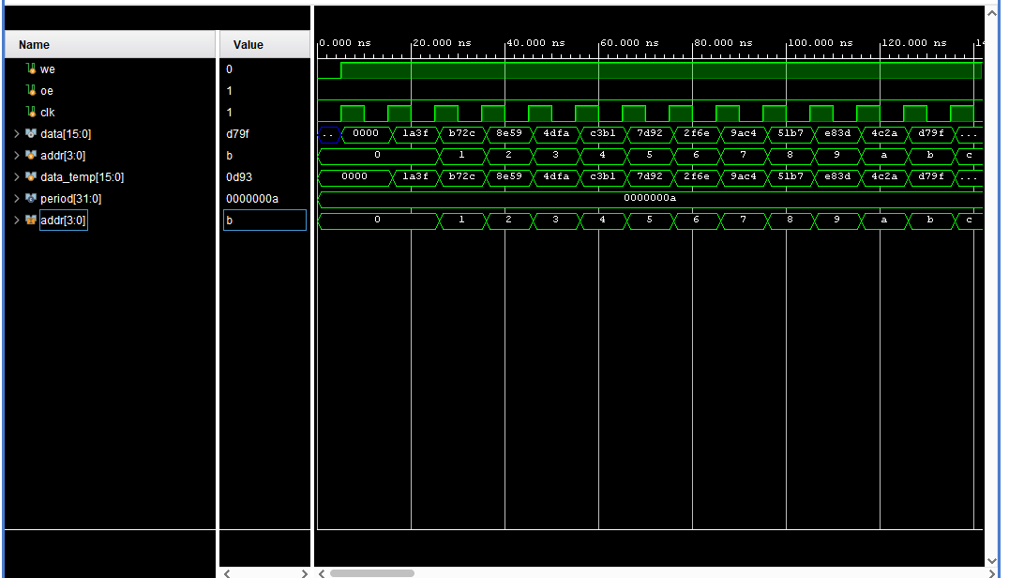
Figure 3: Part One Waveforms

Part 2:
The second part of the lab was like the first, in that we didn’t need to write any code. But I found it to be much more challenging, because it was a lot harder to understand. I will walk through a demonstration of how the code works on the board.
There were two new files to be added. We named them “sseg_x4_top,” and “code_starter.” The code_starter file is at the top in the hierarchy and was the code that was given to us by the instructor. The sseg_x4_top is an adapted version of our seven-segment display lab, from week 6. There wasn’t much that we needed to change in our seven-segment display lab, other than the names of our modules. This was because the code_starter module used different names than we had previously to instantiate the display. This was easy to do and wasn’t really an issue for us. The difficult part was understanding the code_starter file.
To understand the code that was given to us, my partner and I decided to do homework 8 first, that is due this Saturday. Although it took a bit of time, it greatly aided our understanding, and we still ended up finishing the lab within the allotted time.
Because we are using a 16x16 SRAM, there are 16 addresses, and each can store 16 bits of information. Using the different commands, we can change the address of interest, write to an address, read from an address, and perform a simple addition operation.
There are 7 operations that can be done using a combination of the up, down, left, right, and center buttons on the FPGA board. They can be seen in Table 1 below.

Up | Increment the address
Down | Decrement the address
Up/Down Simultaneously | Clear the address. Address is now 0x0
Center/Right Simultaneously | Auto increment the address
Left | Select input memory
Right | Select output memory
Left/Center Simultaneously | Write data to input memory address
Table 1: Operations

Let’s go through an example of how to use these operations together on the BASYS3 board. First, we will start with a clean slate. An image of the board directly after the program has been uploaded can be seen in Figure 4 below. In this example, I also set the switches to 0x8881, although this doesn’t matter till the next step. This is because nothing is read or written yet.

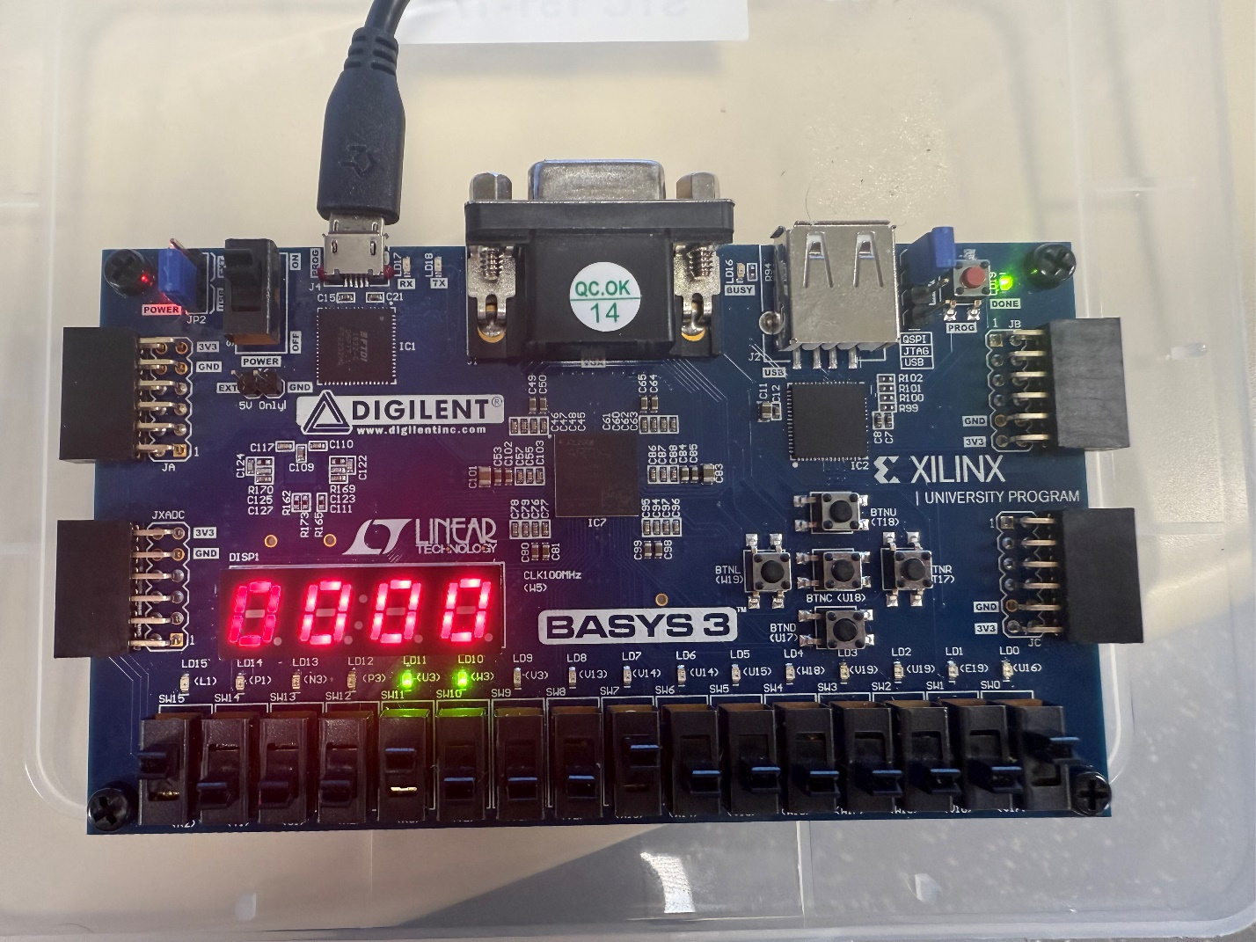
Figure 4: Starting Point

Next, we will use the left and center buttons to write the data 0x8881 to the input memory. This is the value that the switches are currently set to and is now what is displayed on the seven-segment LEDs. This can be seen in Figure 5 below. This value is now stored in the input memory array. To prepare for the next step, we change the switches slightly. In this example, we will change the switches to 0x8883.

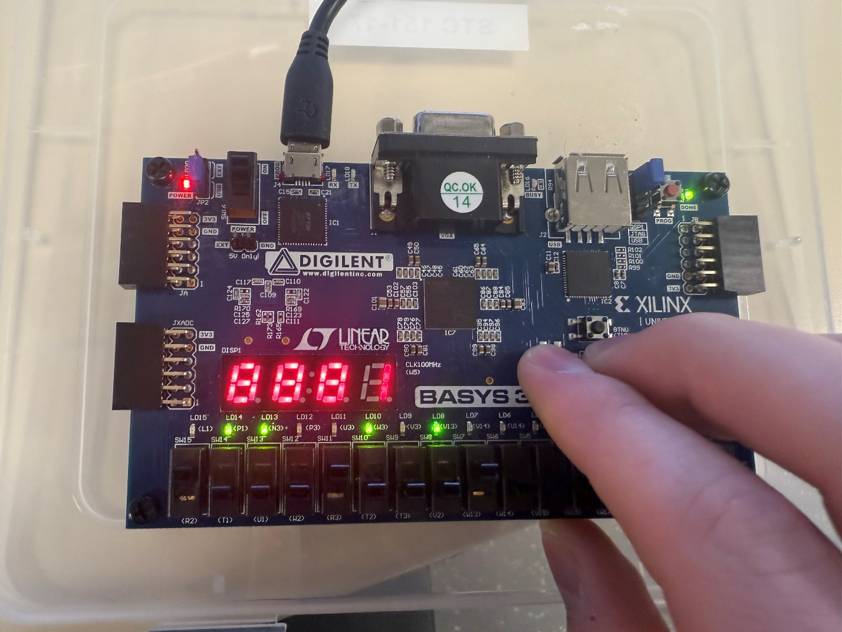
Figure 5: Write Data to Input Memory

Now we will change addresses. To keep it simple, we will press the up button and increment the address by one. This is reflected in the rightmost LED in Figure 6 below. The address is 0x1.
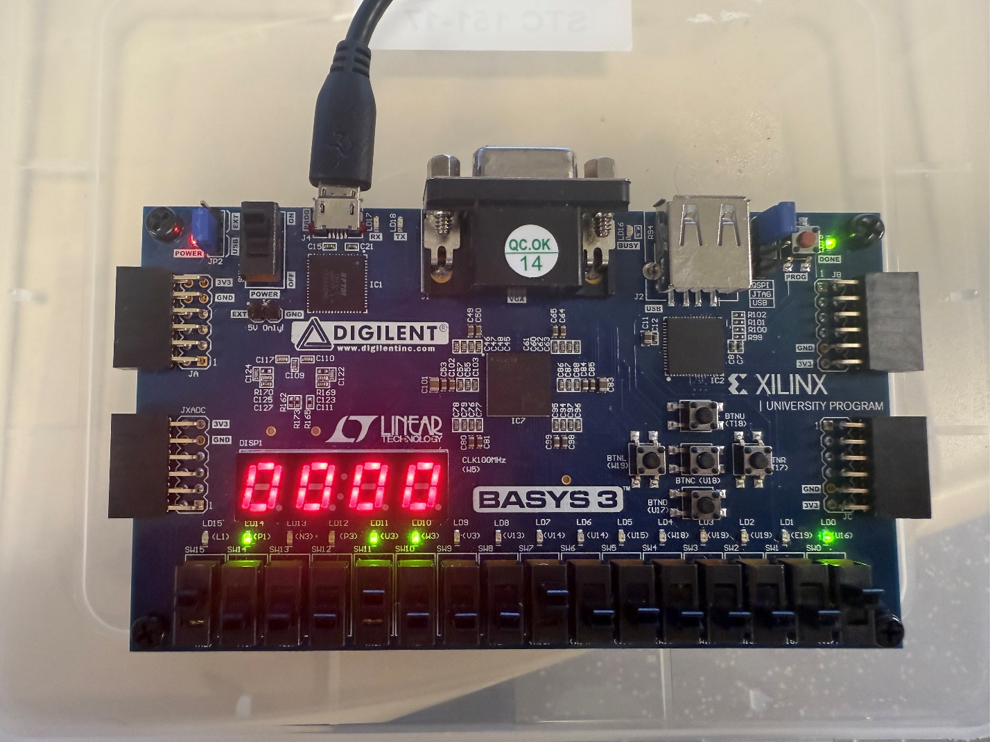
Figure 6: Increment to New Address
Now that we are at the new address, we will write the new data into the input memory at this address. This is again done with the left and center buttons. Figure 7 reflects this, as the LEDs have now changed to 0x8883.
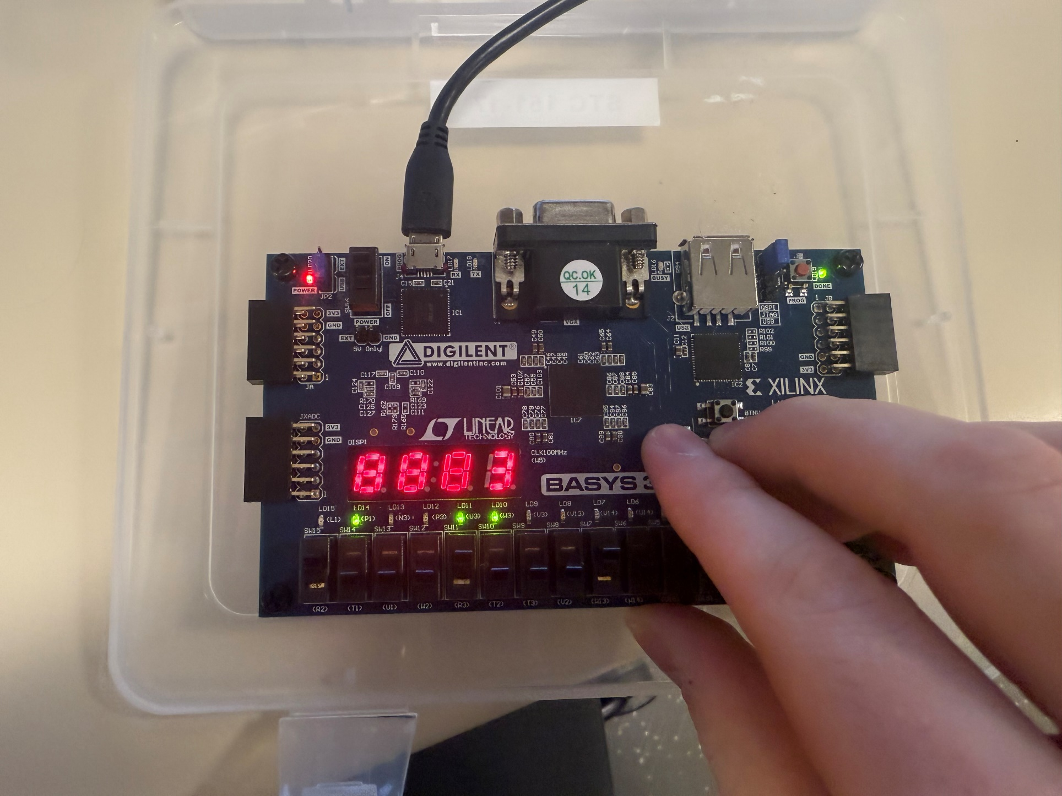
Figure 7: Write to New Address

As a note, if you ever need to select the input memory to display, this can be done by pressing the left button. To view the output memory, press the right button. Figure 8 shows this.

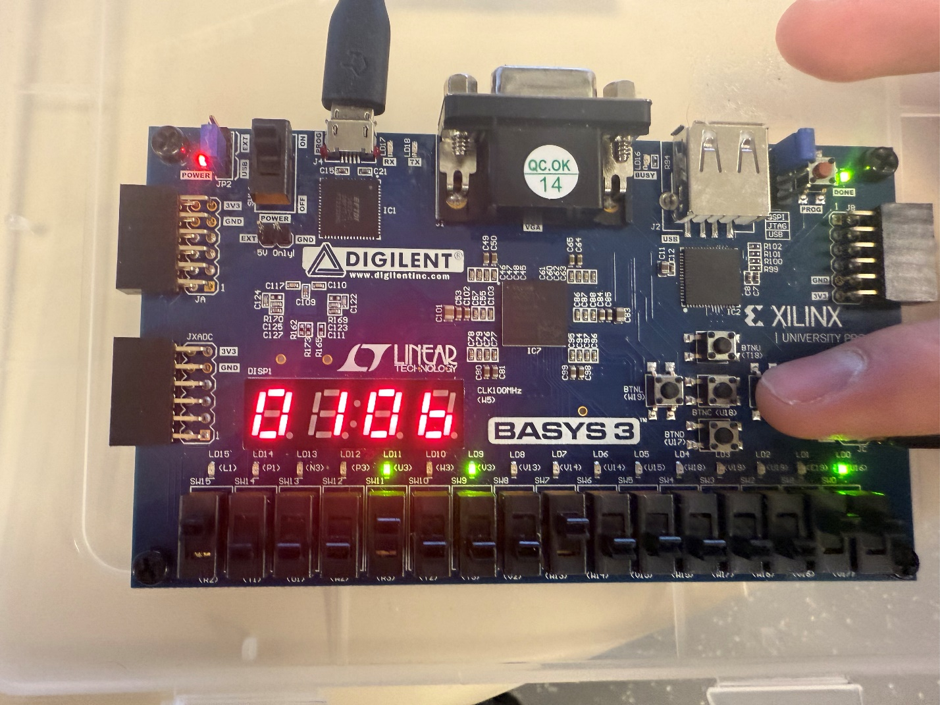
Figure 8: Select Output Memory
Why are the LEDs now displaying 0x0106? This is because the output memory is a simple addition. In this case, the high byte is 0x88 (decimal 136), and the low byte is 0x83 (decimal 131). The result of this operation is 136 + 131 = 267 = 0x0106.
That leaves us with only two more operations: The auto increase, and the clear address functions. An image of the first can be seen in Figure 9. This is done by pressing the center and right buttons simultaneously. Because the clock is 100 MHz, the increase is extremely fast. To our human eyes, it appears to go from whatever value you started at (in our case 0x1) straight to 0xF. If we wanted the incrementation to be more visible, we would have to slow the clock way down. So, with the code we were given, it isn’t much of a useful function, unless we specifically want to go to address 0xF.

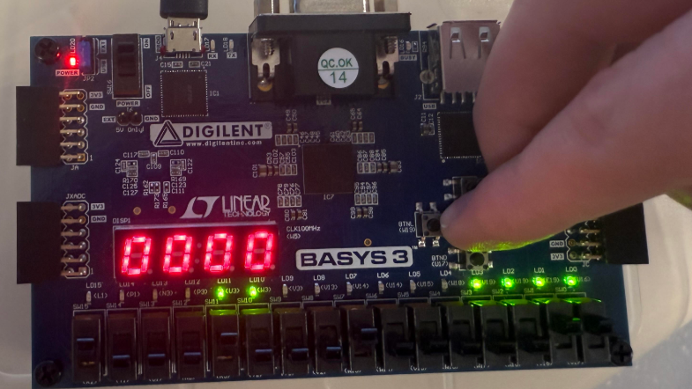
Figure 9: Auto Increase Address

The last function is clearing the address or going to address 0x0. This is done by pressing the up and down buttons simultaneously and can be seen in Figure 10. Notice, the LEDs now display 0x8881. Why is that? Because that is what we stored at address 0x0 at the very beginning of the demonstration! This shows that our input memory is working properly.

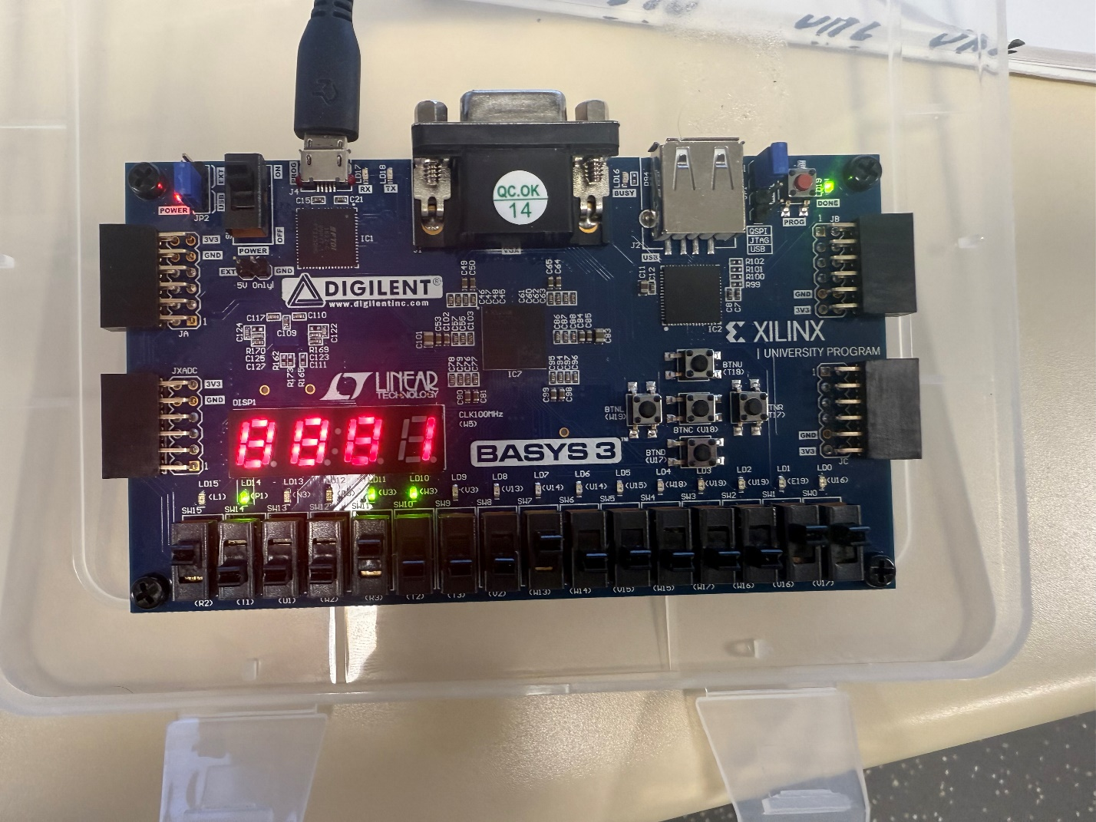
Figure 10: Clear Address

To wrap up, Figure 11 shows the schematic of the completed version of this lab. 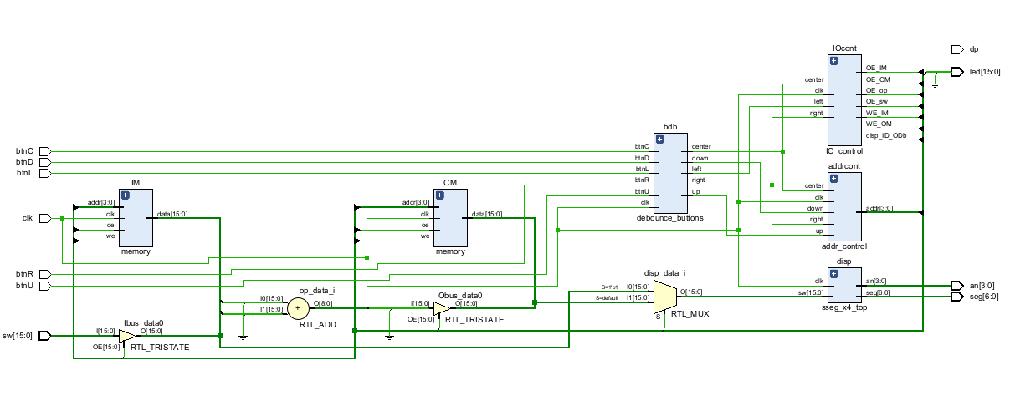
Figure 11: Part Two Schematic

Conclusion:
This lab was the toughest for me thus far. It is one thing to be able to write code, and it is a completely different thing to be able to understand it. But in this lab, we learned how to understand Verilog code that someone else has written, and how to use it.
The final product was a working 16x16 SRAM. We were able to change between 16 addresses, store data in them directly with the switches, and store other data in them with a simple additional operation. This helped me to learn more about static memory, which means that the data is stored when the board has power. When we disconnected the board or ran the program again, everything cleared. This is useful in many systems, because we don’t always want to keep data forever.

